Lab 12 Design and Analysis of Algorithms

Name: Tanvi Penumudy

Enroll No: E18CSE187

Batch: EB06

**Implementation of Randomized Quick Sort Algorithm**

**Question:**

In this lab, you are expected implement the randomized quick sort algorithm where you select the pivot, in each round, uniformly random from the set of elements. This can be done by generating a random number / integer between 1 to n, where n is the size of the input. Further, show us the input in each round, pivot, and partition of the input array explicitly for the following input: 10,5,7,9,12,17,4,8,2,11

**Implementation:** (Code on Notepad)

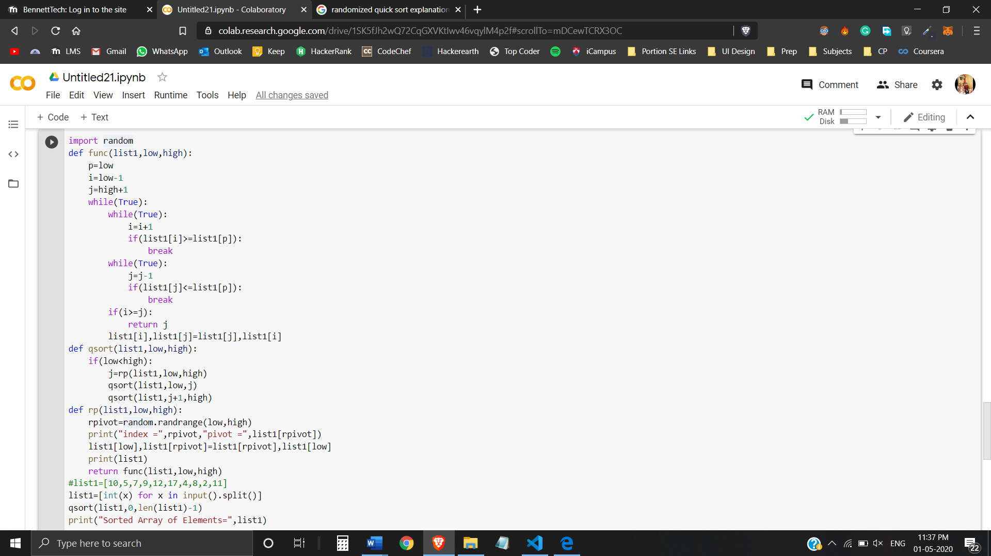

**Output:**

Running the Code Twice:

1st O/P:

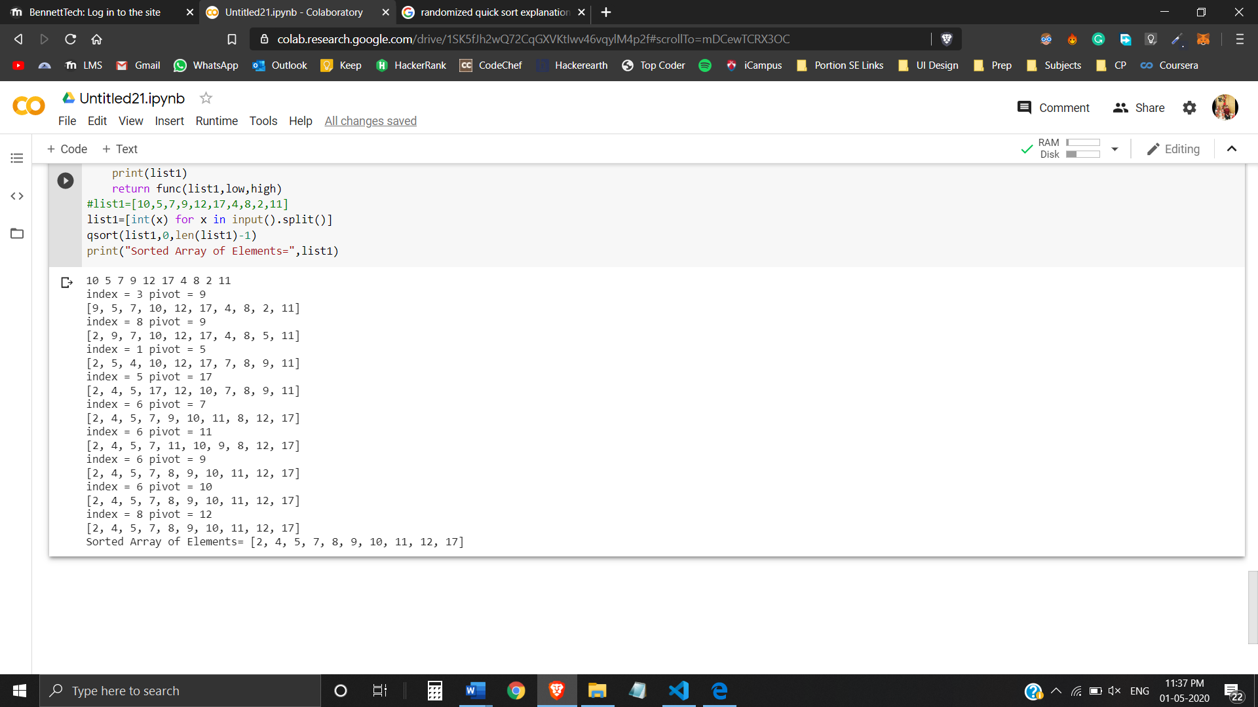

2nd O/P:

